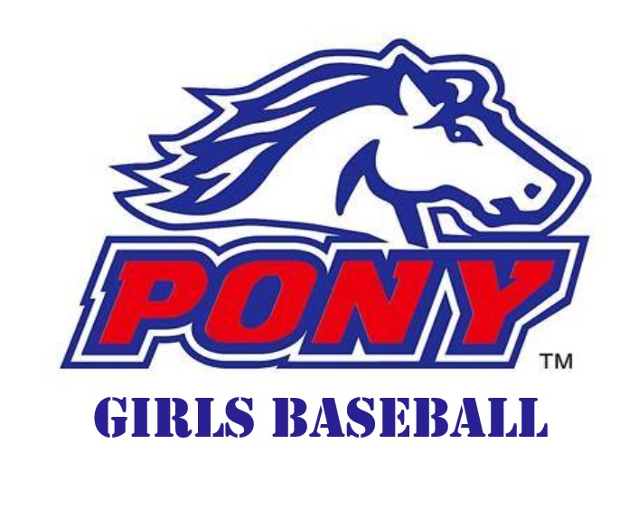

A female-specific player pathway is key to the success of growth in female participation and works towards achieving the goals set by the BWA Board in the Strategic Plan from time-to-time.

The pathway flows from tee-ball to entry level baseball to a more advanced junior baseball environment through to adult women's baseball.

This document serves to document the current programs in operation aimed at the growth of the entry level and advanced junior baseball participants.

BWA has taken the decision to align our programs with Pony League International as this is the only youth sport organisation currently in operation that has a dedicated female baseball pathway.

This document should be read in conjunction with the BWA Tournament Flowchart located on the BWA website - [J001012_BWA Tournament flowcharts x 2_S3.pdf](https://baseballwa-my.sharepoint.com/:b:/r/personal/support_baseballwa_asn_au/Documents/LLWA%20Website%20items/J001012_BWA%20Tournament%20flowcharts%20x%202_S3.pdf?csf=1&web=1&e=k1RSLU)

Aside from the program outlines in this document, BWA also participates in Barclay Cup and Pony World Series events. We also continue to work with TBAWA on the growth of female participation in tee-ball and transition into baseball and with Baseball Australia on providing national youth team opportunities at the top end of the player performance pathway.

**PONY YOUTH** **GIRLS BASEBALL LEAGUE**

The BWA Pony Youth Girls Baseball League (PGL) will offer all females of League Age 13 to 16 the opportunity to play in a "league of their own" (age cutoff of 31 August in the year after the season has finished applies). 17 yo's who have not played two or more seasons of Baseball are also encouraged to participate.  
  
Games will commence in mid-November and conclude prior to Easter.  
  
The purpose of the League is to:

* Provide teenage girls with a competitive game environment to compete, participate and develop.
* Whilst winning and losing is part of any League, individual enjoyment and improvement is the main focus.

BWA clubs can register to be a female "Pathway Club” which grants those clubs with a license to operate one or more teams in the program. To be considered a Pathway Club, the following must be prepared and submitted to BWA by 31 March annually.

1. A female participation plan inclusive of player recruitment and retention activities, a formal relationship with a tee-ball feeder system and other external partners.
2. Confirmation that the plan has been fully costed and such cost has been included in the approved club annual budget.

Once approved as a Pathway Club, a club is free to market themselves as a Pony League club and registration of membership to clubs will be included in BWA marketing material.

Administrative Operations

* Players shall register with the Pathway Club of their choice. Players who are members of clubs who are not eligible Pathway Clubs may register for the program in a Pathway Club without needing to transfer from their regular club. They can participate in open competitions and this program with two different clubs concurrently.
* Clubs shall set up a specific registration category for PGL and use the appropriate BWA membership category.
* All players must be registered as PGL players before playing their first game of the season. Players registered with the club but not specifically as PGL players are not eligible to play.
* The BWA registration cost will be automatically added to the cost of registration on top of the registration fee charged by the club. The BWA registration fee component shall provide each player and three coaches with a numbered player tee shirt and player cap, both to be worn on game days.
* A password protected kitstore portal shall be created and clubs shall order caps and tees within the approved per player budget.
* Where one or more clubs do not have sufficient players to form teams on their own, they shall create combined teams under neutral branding and colours.
* Clubs are always responsible for sourcing coaches, umpires and scorers. Where WABUA can source umpires, the clubs involved shall be informed by WABUA and the usual costs invoiced to them by WABUA.
* All coaches must have a minimum of Certification B coaching accreditation.
* All aspects of Section 12 of the BWA Junior Regulations "Breaches of Regulations” shall apply.
* Players participating in PGL will be given priority selection to any BWA teams competing in Pony League run events.

On-field Operations

All rules contained in the Game By-Laws section of the BWA Junior Regulations shall apply except as otherwise outlined in this document.

* Junior League regular season rules shall apply.
* An offensive inning is complete with a 3rd out or a 6th run. The offensive inning will end at the completion of the play where the 6th run was scored. More than the maximum of 6 runs may have been scored during the final play, however only 6 runs will be recorded for the inning.
* National female bat regulations shall apply Rule 38.4.3 - https://staging.cms.baseball.com.au/app/uploads/2019/07/Technical-Norms.pdf
* All players must play in black pants.
* Games shall be scheduled for the late afternoon timeslot on Sundays. Additional games midweek may be scheduled from time to time at venues able to facilitate night games – any costs involved in these games will be at the cost to the club.

2023-24 Pathway Clubs: Willetton, Kelmscott, Braves, Kalamunda, Carine, Wanneroo, Morley.

PROGRAM COST:

$150 – includes program cap, playing tee, usage of Baseball Park and equipment.

Not included – to be charged as needed by the club – insurance, umpires, match balls, other club costs.

**PONY YOUTH** **GIRLS BASEBALL FUTURES**

The Baseball WA Futures (PGF) is an ideal way for female players to grow and develop their skills in an all-girl environment. It is held annually in Term 1. In some cases, a start time in Term 4 can be used.

The program is for female athletes aged 10 through 13 years old. 9-year-olds not otherwise playing baseball are also encouraged to register.

Players will experience two sessions per week as either training or games. One session (usually a game) will occur in the Sunday lunchtime timeslot. In the first two weeks, the midweek and weekend sessions will be "Spring Training" for all teams combined at Baseball Park.

Game scores are not kept allowing coaches to put players in positions to gain valuable experience that girls often miss out on if only playing Saturday juniors - including pitching, catching and key infield positions.  
  
We highly recommend this program to:

* Girls playing junior baseball
* Girls coming out of or currently playing tee ball or softball
* Girls who have not played diamond sports before or have not played for some years

Administrative Operations

* Players shall register with the Pathway Club of their choice. Players who are members of clubs who are not eligible Pathway Clubs may register for the program in a Pathway Club without needing to transfer from their regular club. They can participate in open competitions and this program with two different clubs concurrently.
* Four regions shall operate located North-East, South-East, West and South-West – Pathway Clubs shall be allocated to regions and work together to run their squads.
* Clubs shall set up a specific registration category for PGF and use the appropriate BWA membership category.
* All players must be registered as PGF participants.
* The BWA registration cost will be automatically added to the cost of registration on top of the registration fee charged by the club. The BWA registration fee component shall provide each player and three coaches with a think.again training tee shirt and player cap. BWA will provide a set of uniform tops to be used during games.
* Clubs are always responsible for sourcing coaches, umpires and scorers. Where WABUA can source umpires, the clubs involved shall be informed by WABUA and the usual costs invoiced to them by WABUA.
* All coaches must have a minimum of Certification B coaching accreditation.

Game Operations

All rules contained in the Game By-Laws section of the BWA Junior Regulations shall apply except as otherwise outlined in this document.

* Intermediate League regular-season rules shall apply, including the diamond size (50/70); but when agreed to by both coaches, the Little League-Major-sized diamond (60/46) can be used.
* No player may pitch if they pitched in regular club ball on the same weekend.
* No player may pitch more than 2 innings per game.
* No player may catch more than 3 innings per game.
* All players shall be in the batting line up. The minimum number of batters shall be six (6).
* No player shall spend consecutive fielding innings on the bench.
* Teams shall only field with six (6) fielders in standard infield / pitcher / catcher positions.
* Games at the start of the program shall utilise the BlueFlame Machine and operate as Machine Pitch (MP60/MP70). The number of games/weeks shall be determined by the Program Delivery Officer.
* A home run fence (cones) must be used and be approximately 100 feet / 30 metres (perfect arc) from home plate. Any batted ball that crosses the home run fence on the full shall be awarded a double and all runners on base shall advance two bases. Any batted ball that crosses the home run fence having bounced prior shall be awarded a single and all runners on base shall advance one base.
* While lead offs are permitted, no player may “steal” from second to third base or from third base to home. Advancing on wild pitches is permitted (note: when playing MP60/MP70 format, no stealing is permitted).
* A batting inning shall conclude with either the third out or the fourth run scored in that inning.
* All batters shall be encouraged to "swing the bat". Coaches and umpires are empowered to remove the "walk” from the game where it is apparent that participants are consistently not swinging at hittable pitches.
* Games shall be at least 90 minutes long, but game time may be extended 30 minutes by agreement of the two coaches.
* No official score shall be kept.
* National female bat regulations shall apply Rule 38.4.3 - https://staging.cms.baseball.com.au/app/uploads/2019/07/Technical-Norms.pdf
* All players must play in black pants.
* Games shall be scheduled for the lunchtime timeslot on Sunday afternoons. Additional training/games midweek may be scheduled from time to time at venues able to facilitate night games – any costs involved in these games will be at the cost to the club.

Pathway Clubs / Regions 2023-24:

WEST – Carine

NORTH-EAST – Wanneroo, Morley

SOUTH-WEST – Braves, Willetton

SOUTH-EAST – Kalamunda, Kelmscott

PROGRAM COST:

$150 – includes program cap, think.again training tee, usage of uniform top, payment to team coach, usage of Baseball Park and equipment.

Not included – to be charged as needed by the club – insurance, umpires, match balls, other club costs.